How to Change Your password in CMiC:

In order to change your password, simply follow the instructions below:

- Open the CMiC Password Manager at https://reset.swinerton.com/r/aexp4b.asp and login using your current username and password.
- The Password Manager page will load with your User Name defaulted in. Enter your current, or “Old” password, then your New password and confirm your new password by re-entering it. Click OK.
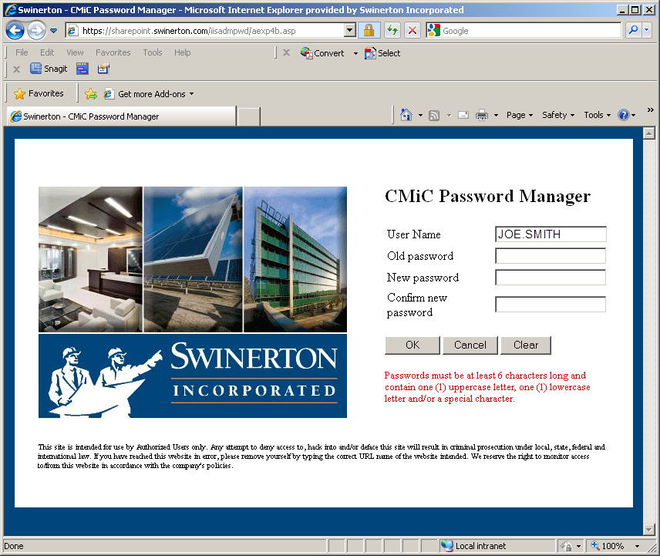
- Return to CMiC at https://cmicweb.swinerton.com/cmicprod/SdMenu/ and login using your new password.

